Student’s Name
Institution Affiliation
Name of the Professor
Date of Submission

Dada is a movement that primarily involved visual arts, poetry, art manifestoes, art theory, theatre, and graphic design. This concentrated its anti-war politic by rejecting the prevailing standards in art through anti-art cultural works, which was started during World War 1 and peaked from 1916 to 1920. According to Thompson & Helfand (2018) the New York School with Bradbury Thompson was born from excitement about European modernism and fueled by economic and technological expansion; it became a dominant force in graphic design from the 1940s until the 1970s. In comparison, Art Nouveau is an international decorative style that uses organic, plantlike lines and Signifies bursting of energy or a flow of elegance. The two activities are Dada and the New York school, all detailed graphic work design performed using different styles and had some similarities; we will discuss techniques and types of posters produced by these movements, time, the artist, and improvements in their attractiveness.
According to Lewin, (2019). Bradbury Thompson was born in 1911 in Topeka, where he attended Washburn College, graduating in 1934. He learned all aspects of printing production as art in capper publication where he worked as a designer, later moved to New York in 1938 where he embraced all graphic design and astonished his talent for over sixty years. He worked as an art director at Rogers-Kellogg-Stillson and mademoiselle magazine and later started his teaching career at Yale University. As a teacher, he always taught people how to develop a new idea of making typography art like the architectural beauty and utility with their knowledge of understanding and not copying. He could blend a modernist typographic organization with classic typefaces and historical illustrations, making work more unique and beautiful from others. Thus they regarded him as the father of designing.
Kurt Schwitters was a German artist born in Hanover, Germany, and he worked in several genres and media, including Dadaism, constructivism, surrealism, poetry, sound, painting, sculpture, graphic design, and typography. And what came to be known as installation art and with is the best artwork of periodical Merz. He studied at Kunstakademie in Dresden. Later, he joined the military in 1917, where he began by experimenting with cubist and Expressionist styles and later created types of his own Rasula, (2020). His creative work included art, collage, and poetry, which he self-published from 1923 through 1932, where it covered a new topic for each issue and featured artist profiles, children's stories, and poetry. As he was comparing the idea and knowledge learned in school and work experience, he quoted, “In the war, things were in terrible turmoil. What I had learned at the academy was of no use to me and the useful new ideas were still unready. Everything had broken down and new things had to be made out of the fragments; and this is Merz. It was like a revolution within me, not as it was, but as it should have been.” He explained the idea of experience in art graphics which is more valuable than the concept learned in school.
Also, as in the introduction, Bradbury Thompson (New York School) and Kurt Switters (Dada) had similarities and differences in their graphic work styles. Dada movement mainly focused on the visual arts, poetry, art manifestoes, art theory, and theatre of graphic design, which were influenced in modern art like it is in Art Nouveau. This makes the relationship between the Dada and the Art Nouveau have a similar style. It's derived from the art nouveau definition that it is a style of art, architecture, and applied art with decorative arts. It also makes Art Nouveau work related to the New York school of graphic work with Thompson as they dealt with artwork of designing magazines and posters with decorative art styles. The two-movement that is Dada and the New York Scholl has a similar kind of using modernist art theory to make art design more attractive by decollating some of their product in a new modern way Varish, (2019)..
Dada and New York School of graphic design were characterized in graphic art design through decorative style and advertising of their design work. They all also worked in topographic art like architecture using the modernist method with cultural art design. From my perspective, Thompson and Kurt art's work was so significant to graphic artwork because some of their work was out of their working experience and not what they studied in school; this made their work more attractive since it involved innovation of modern art design. Creativity and innovation in their graphic artwork made it more significant. Their plans help the 21st century in architecture and are used in college as study notes and experience. In their differences in graphic work, Kurt, who worked in the Dada movement, used traditional culture. They opposed other artwork changes like aesthetics, making them "Anti-art" unlike the New York School. The latter advocated for modern art design, abandoning the traditional culture method and supporting artwork that needed change to improve their work.
As I sum up, Graphic work has primarily increased and helped in career courses, as is evidenced by Thompson Kurt, who used their career to improve the art designs. This artwork has been linked with Art Nouveau, a movement for the painting style experienced by the two artists who used different types to make graphic work more enjoyable, acceptable, and loved by people due to their decorative and modernist style art. Their artwork techniques were well used, like the best artwork of periodical Merz by Kurt, which made it more popular in the graphic work and his work trusted. It was also Thompson with his decorative design where he designed more than 600 magazines in his career. Therefore, innovation, experience, and creativity are all that are needed in graphic artwork.


Designed by Kurt

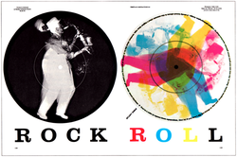
Bradbury Thompson

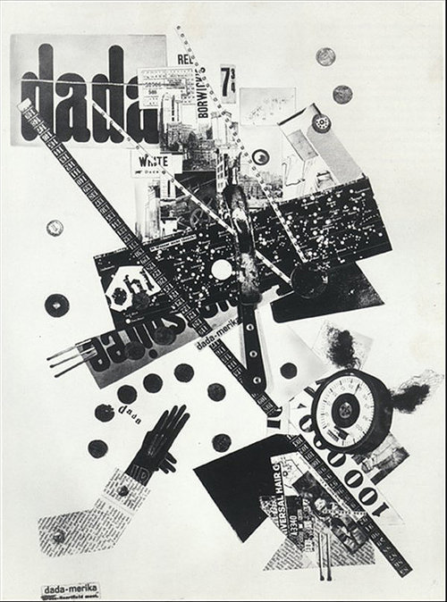
Merz was published and designed by Kurt Schwitters

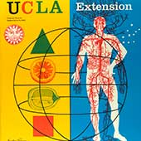
Designed by Bradbury Thompson


Bradbury Thompson
References.
Lewin, M. F. (2019). Artful Bodymind: Enlivening transformative research methodologies.
McVarish, E. (2019). HISTORY FROM ATO Z. Teaching Graphic Design History.
Rasula, J. (2020). Acrobatic Modernism from the Avant-garde to Prehistory. Oxford University Press, USA.
Thompson, B., & Helfand, J. (2018). The art of graphic design. Yale University Press.

